LAB Logbook

Lab 1

<https://github.com/Addict07/Machine-Learning-In-Finance_2025-26/blob/main/LabLogbook_Week_1.ipynb>

Lab 2

<https://github.com/Addict07/Machine-Learning-In-Finance_2025-26/blob/main/LabLogbook_Week_2.ipynb>

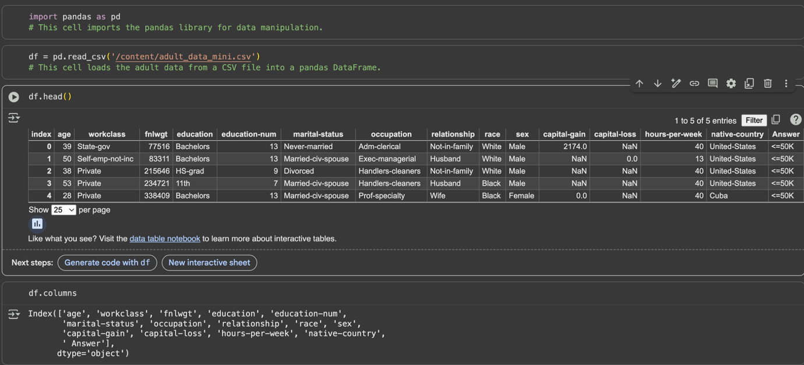

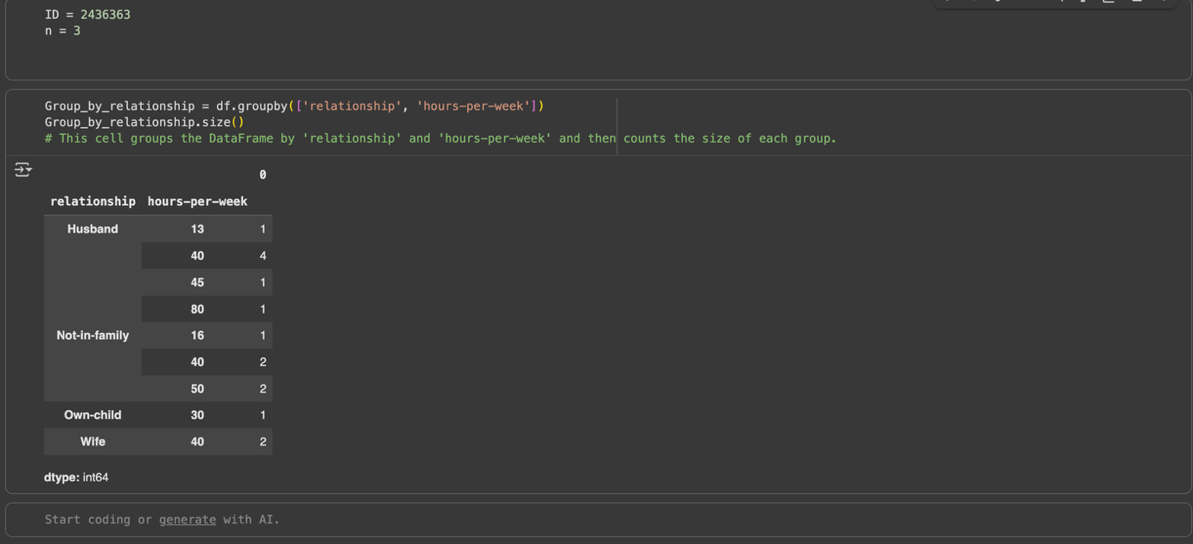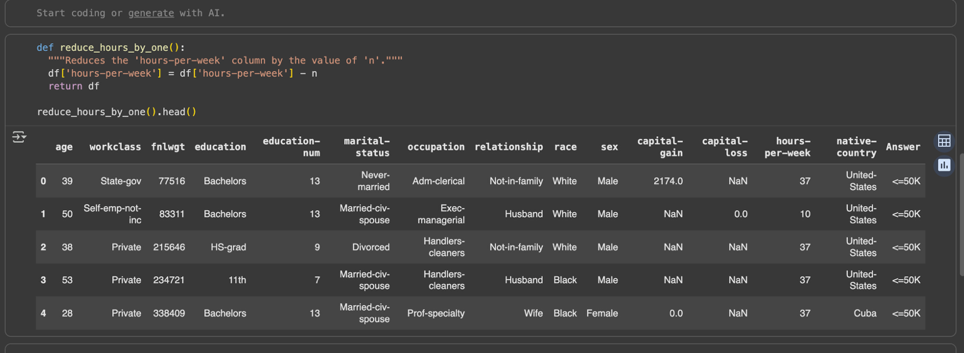

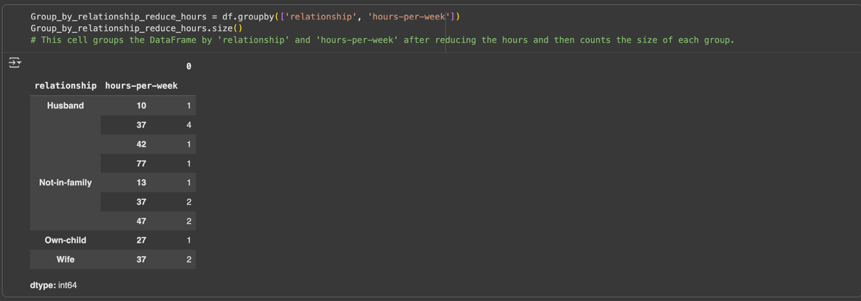

Lab 3

https://github.com/Addict07/Machine-Learning-In-Finance_2025-26/blob/main/LabLogbook_Week_3.ipynb

Lab 4

<https://github.com/Addict07/Machine-Learning-In-Finance_2025-26/blob/main/LabLogbook_Week_4.ipynb>

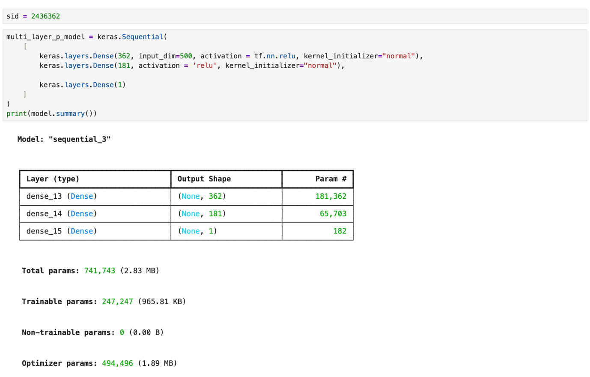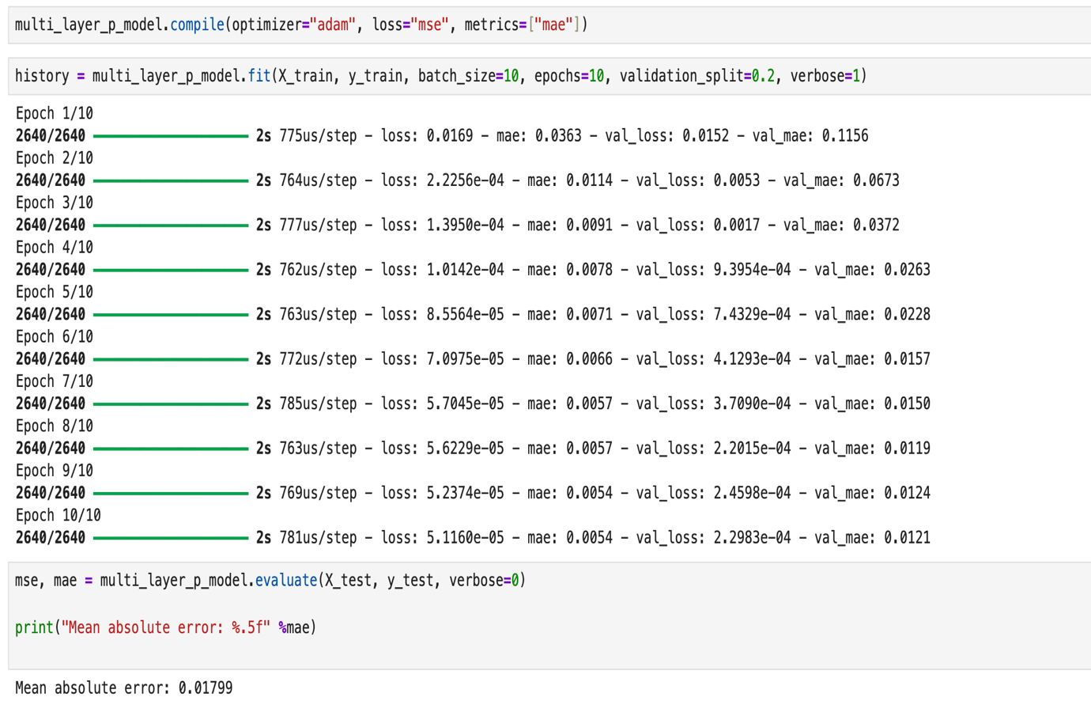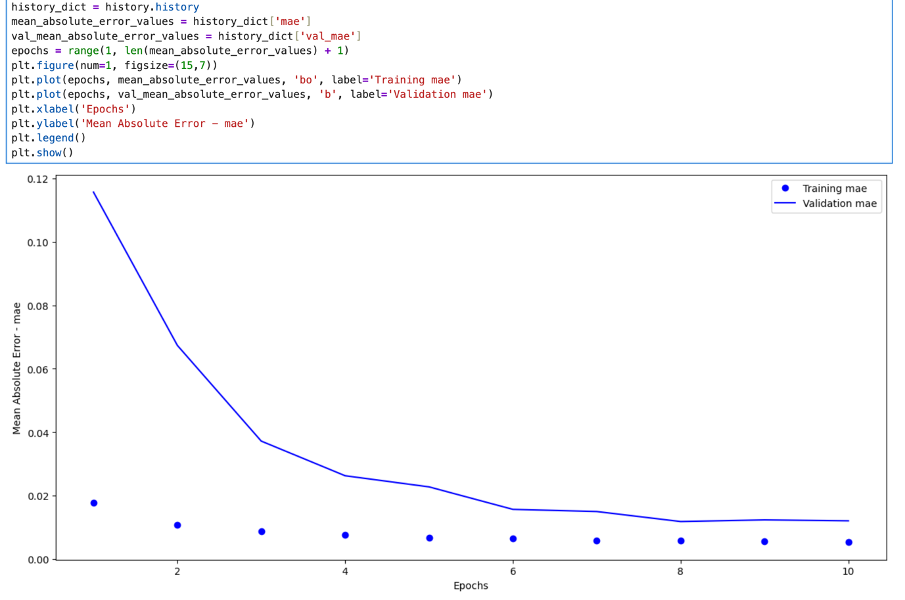

Lab 5

<https://github.com/Addict07/Machine-Learning-In-Finance_2025-26/blob/main/LabLogbook_Week_5.ipynb>

Lab 6

<https://github.com/Addict07/Machine-Learning-In-Finance_2025-26/blob/main/LabLogbook_Week_6.ipynb>

Lab 7

<https://github.com/Addict07/Machine-Learning-In-Finance_2025-26/blob/main/LabLogbook_Week_7.ipynb>

Lab 8

<https://github.com/Addict07/Machine-Learning-In-Finance_2025-26/blob/main/LabLogbook_Week_8.ipynb>

Lab 9

Lab 10

Lab 11

Lab 12